**Policy Information Tile is Common**

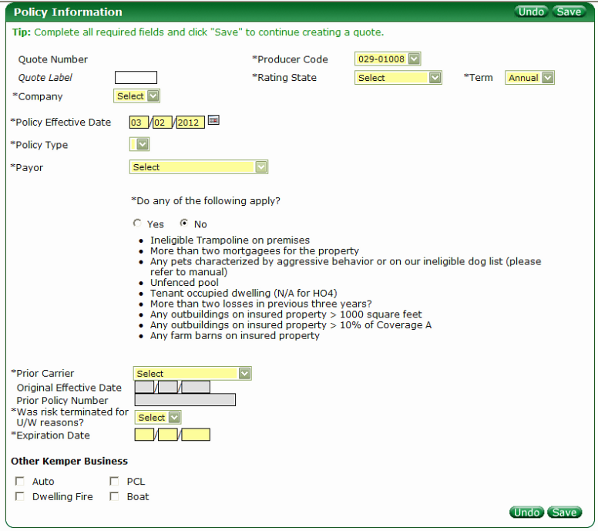

Required Fields to quote are in yellow and all other fields are optional. **Note:** the Original Effective Date and Prior Policy Number are required if the criteria for those fields are met.

* Producer Code (dropdown) – **You will not provide**
  + List of all Producer Codes linked to the login ID.
* Quote Label (freeform field)
  + An optional field to label a quote for downloads search capability.
* Rating State (dropdown) - **You will provide**
  + Currently a list of states where Kemper writes Business
* Term (dropdown) – **You will provide**
  + Annual
* Company (dropdown) - **You will provide -** Filter by State
  + Displays options after State is selected
* Policy Effective Date (freeform field)
  + Currently defaults to current date but can be modified
* Policy Type (dropdown) – **You will provide -** Policy Type – Filter by State
  + Displays options after State is selected (I.e. HO-3, HO-4 and HO-6)
* Payor (dropdown) – **You will provide**
* Do any of the following apply? (Radio button)
  + Yes/No options
    - If Yes then the user cannot quote RPW
* “Do any of the following apply?” – **You will provide**
  + Policy Information Questions – Filter by LOB then by State
  + These questions are different by Line of Business and can vary by State
* Prior Carrier (dropdown) – **You will provide**
  + List of insurance carriers & also used to denote Rewrites if a “Kemper” Company is selected
    - If a Kemper Company is selected then the Original Effective Date and Prior Policy Number fields open up for entry.
* Original Effective Date (freeform field)
  + Only available (becomes enabled )when a Kemper Company is selected for Prior Carrier (Rewrites)
* Prior Policy Number (freeform field)
  + Only available (becomes enabled) when a Kemper Company is selected for Prior Carrier (Rewrites)
* Was risk terminated for U/W reasons? (dropdown) – **You will Provide**
  + Yes/No options
* Expiration (freeform field)
  + This is auto populated with current date after Prior Carrier is selected but can be modified
* Other Policy Information (freeform field)
* Other Kemper Business (checkboxes)
  + Denotes other Lines of Business for the user

**Applicant Tile is Common**

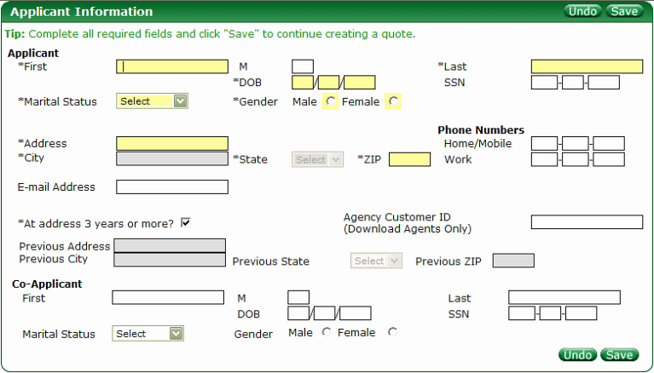

**Applicant**

* First (freeform field)
* M (freeform field)
* Last (freeform field)
* DOB (freeform field)
* SSN (freeform field)
* Marital Status (dropdown) – **You will provide**
* Gender (radio buttons)
  + Male/Female
* Address (freeform field)
* City (freeform field)
  + Auto populated but Location Service look-up when Zip is entered
  + If no information returned from Location Service or bad data entered this field becomes enabled
* State (dropdown) – **You will provide**
  + Auto populated but Location Service look-up when Zip is entered
  + If no information returned from Location Service or bad data entered this dropdown becomes enabled
* Zip (freeform field)
  + Drives Location Service lookup
* Home/Mobile (freeform field)
* Work (freeform field)
* Email (freeform field)
* At address 3 years or more? (checkbox)
  + Default is to have this checked
  + If checked then previous address information remains disabled. If unchecked then previous address information becomes enabled.
* Agency Customer ID (freeform field)
* Previous Address (freeform field)
  + See “At address 3 years or more?” information
* Previous City (freeform field)
  + See “At address 3 years or more?” information
  + Auto populated but Location Service look-up when Zip is entered
  + If no information returned from Location Service or bad data entered this field becomes enabled
* Previous State (dropdown) **You will provide**
  + See “At address 3 years or more?” information
  + Auto populated but Location Service look-up when Zip is entered
  + If no information returned from Location Service or bad data entered this dropdown becomes enabled
* Previous Zip (freeform field)
  + See “At address 3 years or more?” information
  + Drives Location Service lookup

**Co-Applicant**

* First (freeform field)
* M (freeform field)
* Last (freeform field)
* DOB (freeform field)
* SSN (freeform field)
* Marital Status (dropdown) – **You will provide**
* Gender (freeform field)

**Property Tile HO-3** 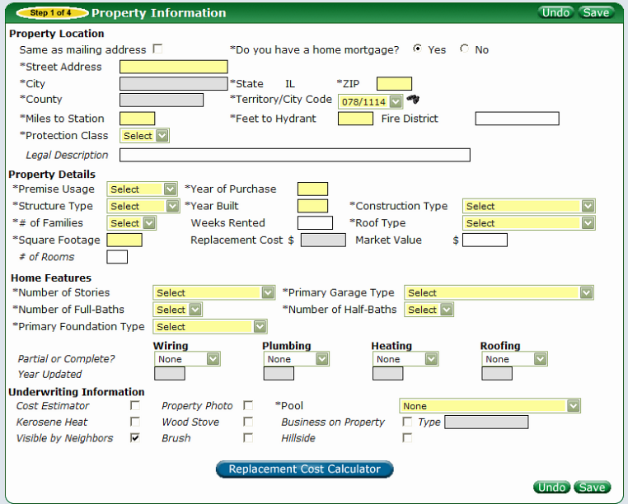

* Same as mailing address (checkbox)
  + Automatically brings down the address from the Applicant Tile and populates it
* *Do you have a home mortgage? (radio buttons) – Filter on State, Company, LOB and Policy Type
  + Specifies that a mortgage is present and will modify the workflow
    - There are cross-references to the selection of the Payor on the Policy Information Tile
* Street Address (freeform field)
* City (freeform field)
  + Auto populated by Location Service if a valid Zip is entered otherwise a manually entered field
* State (freeform field)
  + Disabled and populated with Rating State from the Policy Information Tile
* Zip (freeform field)
  + Drives a call to Location Service upon entry of the 5th digit.
* County (freeform field)
  + Disabled and populated by Location Service
* Territory/City Code (dropdown) – You will provide
  + Populated by Location Service

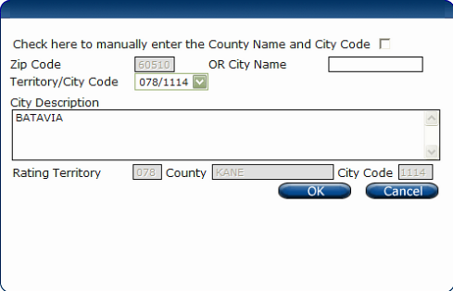

* “Check here to skip territory locator and manually enter the territory (checkbox)
  + - If checked it disables Zip Code and City Name fields but enables City Description, Rating Territory, County and City Code fields
* Zip Code (freeform)
  + - Auto populates with Zip
    - Disabled
* City Name (freeform)
  + - Enabled unless the manually enter the territory checkbox is checked
* Territory/City Code (dropdown) – You will provide
* City Description (freeform)
* Rating Territory (freeform)
  + - Auto populated with Territory value
    - Disabled unless manually enter the territory checkbox is checked
    - If modified this will overwrite the Territory on the Vehicles Tile
* County (freeform)
  + Auto populated with County Name
* City Code (freeform)
  + - Auto populated with City Cod value
    - Disabled unless manually enter the territory checkbox is checked
* If modified this will overwrite the City Code on the Vehicles Tile
* Miles to Station (freeform)
* Feet to Hydrant (freeform)
* Fire District (freeform)
* Protection Class (dropdown) – You will provide
  + Auto look-up to populate the Protection Class based on Property Location
  + Can be manually selected at any point
* Legal Description (freeform)
* Premise Usage (dropdown) – You will provide
* Year of Purchase (freeform) – Filter by State, Company, LOB & Policy Type
* Structure Type (dropdown) – You will provide – Filter on State, Company, LOB & Policy Type
* Year Built (freeform)
* Construction Type (dropdown) – You will provide - Filter on State & LOB
* # of Families (dropdown) – You will provide
* Weeks Rented (freeform)
* Roof Type (dropdown) – You will provide
* Square Footage (freeform)
* Replacement Cost (freeform)
  + Auto populated by 360 value
  + Manually entered when 360 down
* Market Value (freeform)
* # of Rooms (freeform)
* Number of Stories (dropdown) – You will provide – Filter by State, Company, LOB, Policy Type
* Primary Garage Type (dropdown) – You will provide - Filter by State, Company, LOB, Policy Type
* Number of Full-Baths (dropdown) - You will provide - Filter by State, Company, LOB, Policy Type
* Number of Half-Baths (dropdown) - You will provide - Filter by State, Company, LOB, Policy Type
* Primary Foundation Type (dropdown) - You will provide - Filter by State, Company, LOB, Policy Type
* Wiring
  + Partial or Complete (dropdown) – You will provide - If other than None opens Year Updated
  + Year Updated (freeform)
    - Enabled when Partial or Complete is selected
* Plumbing
  + Partial or Complete (dropdown) – You will provide - If other than None opens Year Updated
  + Year Updated (freeform)
    - Enabled when Partial or Complete is selected
* Heating
  + Partial or Complete (dropdown) – You will provide - If other than None opens Year Updated
  + Year Updated (freeform)
    - Enabled when Partial or Complete is selected
* Roofing
  + Partial or Complete (dropdown) – You will provide - If other than None opens Year Updated
  + Year Updated (freeform)
    - Enabled when Partial or Complete is selected
* Cost Estimator (checkbox)
* Property Photo (checkbox)
* Pool (dropdown) – You will provide
* Kerosene Heat (checkbox)
* Wood Stove (checkbox)
* Business on Property (checkbox)
  + Type (freeform)
* Visible by Neighbors (checkbox)
* Brush (checkbox)
* Hillside (checkbox)
* Replacement Cost Calculator (button)
  + Brings user to 360 Value

**Property Information Tile HO-4**

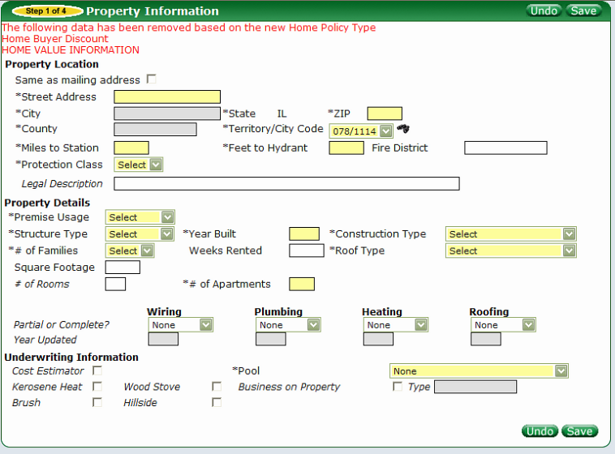

* Same as mailing address (checkbox)
  + Automatically brings down the address from the Applicant Tile and populates it
* Street Address (freeform field)
* City (freeform field)
  + Auto populated by Location Service if a valid Zip is entered otherwise a manually entered field
* State (freeform field)
  + Disabled and populated with Rating State from the Policy Information Tile
* Zip (freeform field)
  + Drives a call to Location Service upon entry of the 5th digit.
* County (freeform field)
  + Disabled and populated by Location Service
* Territory/City Code (dropdown) – You will provide
  + Populated by Location Service



* “Check here to skip territory locator and manually enter the territory (checkbox)
  + - If checked it disables Zip Code and City Name fields but enables City Description, Rating Territory, County and City Code fields
* Zip Code (freeform)
  + - Auto populates with Zip
    - Disabled
* City Name (freeform)
  + - Enabled unless the manually enter the territory checkbox is checked
* Territory/City Code (dropdown) – You will provide
* City Description (freeform)
* Rating Territory (freeform)
  + - Auto populated with Territory value
    - Disabled unless manually enter the territory checkbox is checked
    - If modified this will overwrite the Territory on the Vehicles Tile
* County (freeform)
  + Auto populated with County Name
* City Code (freeform)
  + - Auto populated with City Cod value
    - Disabled unless manually enter the territory checkbox is checked
* If modified this will overwrite the City Code on the Vehicles Tile
* Miles to Station (freeform)
* Feet to Hydrant (freeform)
* Fire District (freeform)
* Protection Class (dropdown) – You will provide
  + Auto look-up to populate the Protection Class based on Property Location
  + Can be manually selected at any point
* Legal Description (freeform)
* Premise Usage (dropdown) – You will provide
* Structure Type (dropdown) – You will provide – Filter on State, Company, LOB & Policy Type
* Year Built (freeform)
* Construction Type (dropdown) – You will provide - Filter on State & LOB
* # of Families (dropdown) – You will provide
* Weeks Rented (freeform)
* Roof Type (dropdown) – You will provide
* Square Footage (freeform)
* # of Rooms (freeform)
* # of Apartments (freeform)
* Wiring
  + Partial or Complete (dropdown) – You will provide - If other than None opens Year Updated
  + Year Updated (freeform)
    - Enabled when Partial or Complete is selected
* Plumbing
  + Partial or Complete (dropdown) – You will provide - If other than None opens Year Updated
  + Year Updated (freeform)
    - Enabled when Partial or Complete is selected
* Heating
  + Partial or Complete (dropdown) – You will provide - If other than None opens Year Updated
  + Year Updated (freeform)
    - Enabled when Partial or Complete is selected
* Roofing
  + Partial or Complete (dropdown) – You will provide - If other than None opens Year Updated
  + Year Updated (freeform)
    - Enabled when Partial or Complete is selected
* Cost Estimator (checkbox)
* Pool (dropdown) – You will provide
* Kerosene Heat (checkbox)
* Wood Stove (checkbox)
* Business on Property (checkbox)
  + Type (freeform)
* Brush (checkbox)
* Hillside (checkbox)

**Property Tile HO-6**

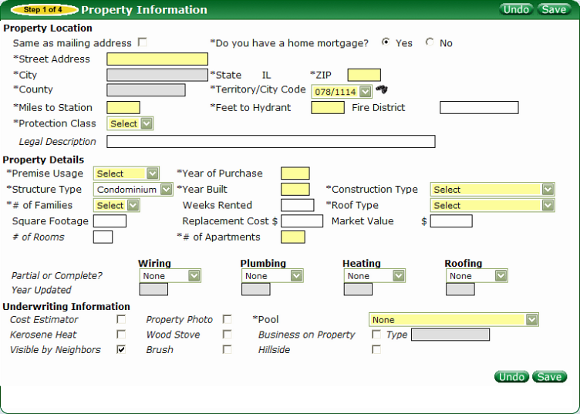

* Same as mailing address (checkbox)
  + Automatically brings down the address from the Applicant Tile and populates it
* *Do you have a home mortgage? (radio buttons) – Filter on State, Company, LOB and Policy Type
  + Specifies that a mortgage is present and will modify the workflow
    - There are cross-references to the selection of the Payor on the Policy Information Tile
* Street Address (freeform field)
* City (freeform field)
  + Auto populated by Location Service if a valid Zip is entered otherwise a manually entered field
* State (freeform field)
  + Disabled and populated with Rating State from the Policy Information Tile
* Zip (freeform field)
  + Drives a call to Location Service upon entry of the 5th digit.
* County (freeform field)
  + Disabled and populated by Location Service
* Territory/City Code (dropdown) – You will provide
  + Populated by Location Service



* “Check here to skip territory locator and manually enter the territory (checkbox)
  + - If checked it disables Zip Code and City Name fields but enables City Description, Rating Territory, County and City Code fields
* Zip Code (freeform)
  + - Auto populates with Zip
    - Disabled
* City Name (freeform)
  + - Enabled unless the manually enter the territory checkbox is checked
* Territory/City Code (dropdown) – You will provide
* City Description (freeform)
* Rating Territory (freeform)
  + - Auto populated with Territory value
    - Disabled unless manually enter the territory checkbox is checked
    - If modified this will overwrite the Territory on the Vehicles Tile
* County (freeform)
  + Auto populated with County Name
* City Code (freeform)
  + - Auto populated with City Cod value
    - Disabled unless manually enter the territory checkbox is checked
* If modified this will overwrite the City Code on the Vehicles Tile
* Miles to Station (freeform)
* Feet to Hydrant (freeform)
* Fire District (freeform)
* Protection Class (dropdown) – You will provide
  + Auto look-up to populate the Protection Class based on Property Location
  + Can be manually selected at any point
* Legal Description (freeform)
* Premise Usage (dropdown) – You will provide
* Year of Purchase (freeform) – Filter by State, Company, LOB & Policy Type
* Structure Type (dropdown) – You will provide – Filter on State, Company, LOB & Policy Type
* Year Built (freeform)
* Construction Type (dropdown) – You will provide - Filter on State & LOB
* # of Families (dropdown) – You will provide
* Weeks Rented (freeform)
* Roof Type (dropdown) – You will provide
* Square Footage (freeform)
* Replacement Cost (freeform)
  + Manually entered
* Market Value (freeform)
* # of Rooms (freeform)
* # of Apartments
* Wiring
  + Partial or Complete (dropdown) – You will provide - If other than None opens Year Updated
  + Year Updated (freeform)
    - Enabled when Partial or Complete is selected
* Plumbing
  + Partial or Complete (dropdown) – You will provide - If other than None opens Year Updated
  + Year Updated (freeform)
    - Enabled when Partial or Complete is selected
* Heating
  + Partial or Complete (dropdown) – You will provide - If other than None opens Year Updated
  + Year Updated (freeform)
    - Enabled when Partial or Complete is selected
* Roofing
  + Partial or Complete (dropdown) – You will provide - If other than None opens Year Updated
  + Year Updated (freeform)
    - Enabled when Partial or Complete is selected
* Cost Estimator (checkbox)
* Property Photo (checkbox)
* Pool (dropdown) – You will provide
* Kerosene Heat (checkbox)
* Wood Stove (checkbox)
* Business on Property (checkbox)
  + Type (freeform)
* Visible by Neighbors (checkbox)
* Brush (checkbox)
* Hillside (checkbox)

**Home Policy Coverages Tile HO-3**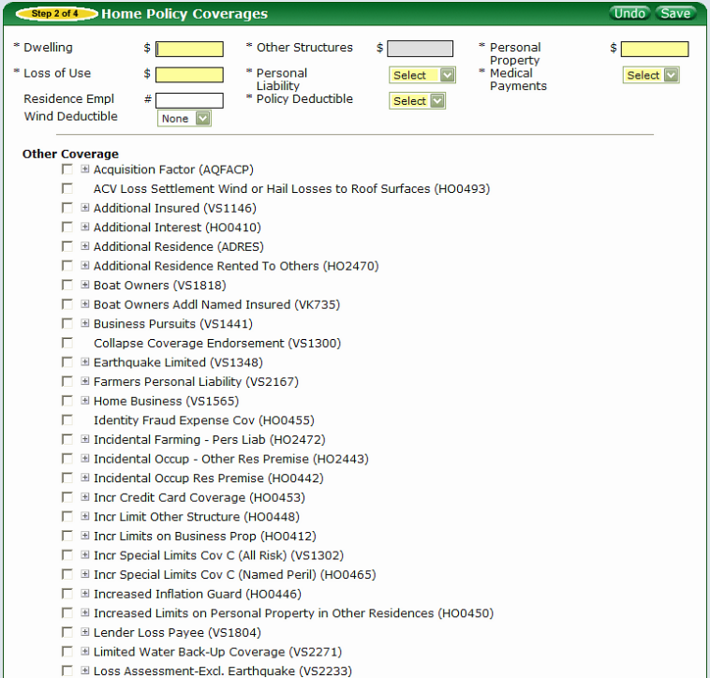 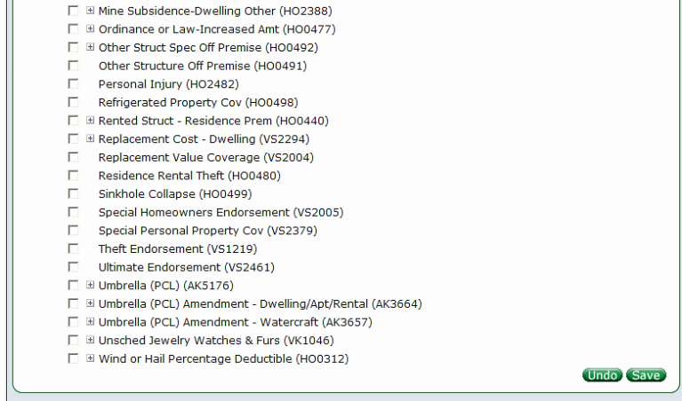

* Dwelling (freeform) – Filtered by State, Company, LOB, Policy Type
* Other Structures (freeform) – Filtered by State, Company, LOB, Policy Type
  + Disabled
  + Auto populated based on value entered into Dwelling (set %)
* Personal Property (freeform) – Filtered by State, Company, LOB, Policy Type
  + Auto populated based on value entered into Dwelling (set %)
  + Can be manually entered
* Loss of Use (freeform) – Filtered by State, Company, LOB, Policy Type
  + Auto populated based on value entered into Dwelling (set %)
  + Can be manually entered
* Personal Liability (dropdown) – You will provide
* Medical Payments (dropdown) – You will provide
* Residence Empl (freeform) – Filtered by State, Company, LOB, Policy Type
* Policy Deductible (dropdown) - You will provide – Filtered by State, Company, LOB, Policy Type
* Wind Deductible (dropdown) – You will provide – Filtered by State, Company, LOB, Policy Type
* Other Coverage
  + These endorsements are filtered by State, Company, LOB, Policy Type

**Home Policy Coverages HO-4**

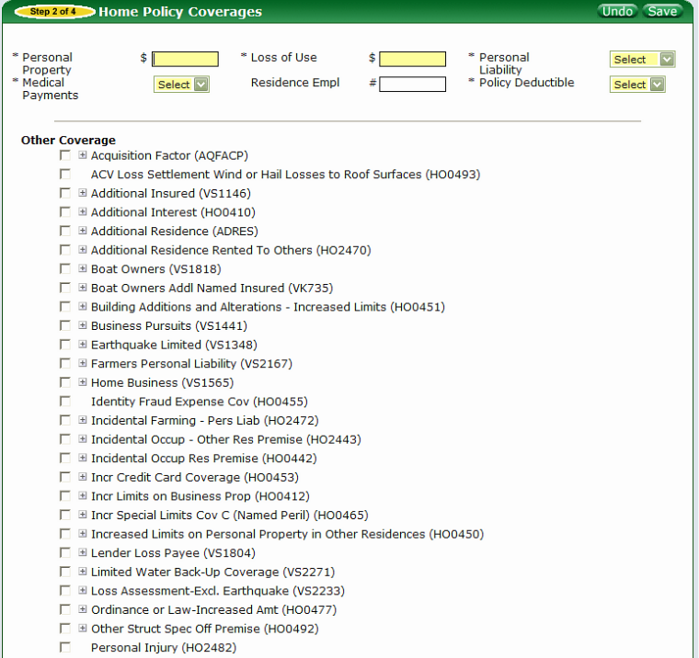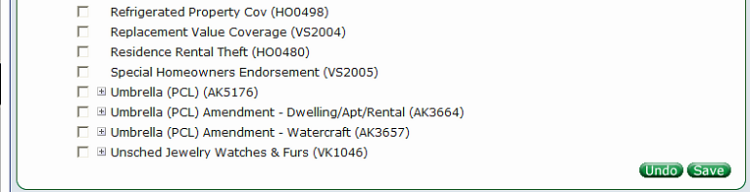

* Personal Property (freeform) – Filtered by State, Company, LOB, Policy Type
* Loss of Use (freeform) – Filtered by State, Company, LOB, Policy Type
  + Auto populated based on value entered into Dwelling (set %)
  + Can be manually entered
* Personal Liability (dropdown) – You will provide
* Medical Payments (dropdown) – You will provide
* Residence Empl (freeform) – Filtered by State, Company, LOB, Policy Type
* Policy Deductible (dropdown) - You will provide – Filtered by State, Company, LOB, Policy Type
* Other Coverage
* Other Coverage
  + These endorsements are filtered by State, Company, LOB, Policy Type

**Home Policy Coverages HO-6**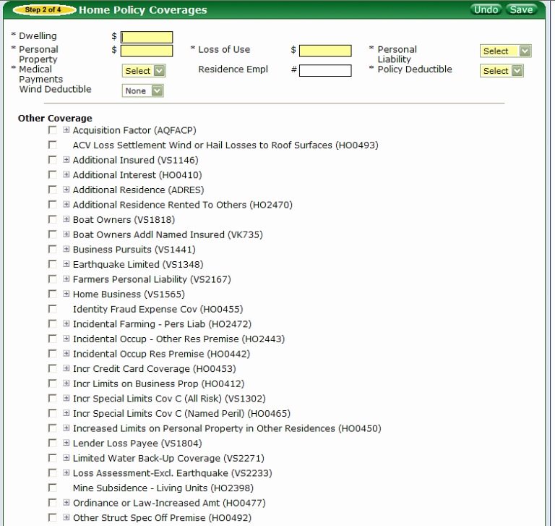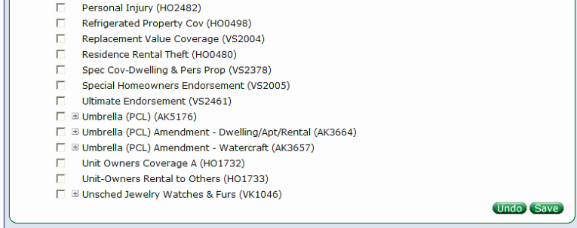

* Dwelling (freeform) – Filtered by State, Company, LOB, Policy Type
  + Auto populated based on the value entered into the Personal Property field (set %)
  + Can be manually entered
* Personal Property (freeform) – Filtered by State, Company, LOB, Policy Type
  + Manually entered
* Loss of Use (freeform) – Filtered by State, Company, LOB, Policy Type
  + Auto populated based on value entered into Personal Property (set %)
  + Can be manually entered
* Personal Liability (dropdown) – You will provide
* Medical Payments (dropdown) – You will provide
* Residence Empl (freeform) – Filtered by State, Company, LOB, Policy Type
* Policy Deductible (dropdown) - You will provide – Filtered by State, Company, LOB, Policy Type
* Wind Deductible (dropdown) – You will provide – Filtered by State, Company, LOB, Policy Type
* Other Coverage
  + These endorsements are filtered by State, Company, LOB, Policy Type

**Home Discounts Tile (HO-3, HO-4 & HO-6)**

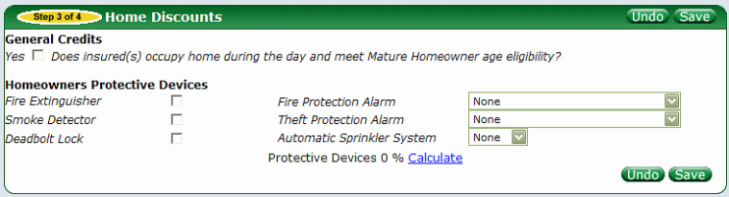

* General Credits section – Filtered by State, Company, LOB & Policy Type
  + Here checkboxes will be available with a description of the discount available. I.e. age dependent discounts, Year built discounts, non-smoking etc…. These will display in the section with a checkbox.
* Homeowners Protective Devices section – Filtered by State, Company, LOB & Policy Type
  + Fire Extinguisher (checkbox)
  + Smoke Detector (checkbox)
  + Deadbolt Lock (checkbox)
  + Fire Protection Alarm (dropdown) – You will provide
  + Theft Protection Alarm (dropdown) – You will provide
  + Automatic Sprinkler System (dropdown) – You will provide
  + Protective Devices 0% (Calculate link)
    - This will display the total discount based on the selections when the “calculate” link is selected.

**Incidents Tile(HO-3, HO-4 & HO-6)**

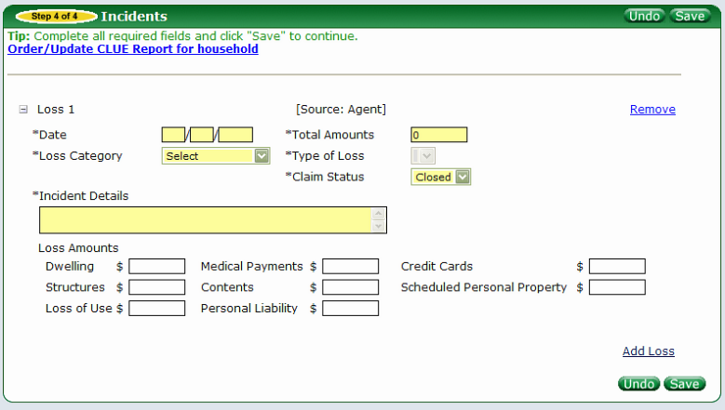

* Order/Update CLUE Report for household
  + Link to manually order reports
* User can add a loss with the “Add Loss” link or it can be returned from Choicepoint
  + If returned from Choicepoint the Loss information is disabled and the user can only Accept or Dispute the loss
  + For Manually added losses:
    - Date (freeform)
    - Total Amounts (freeform)
      * Can be manually added and remain enabled unless a value is entered into the Loss Amounts section.
      * Auto populated based on the values entered into the Loss Amounts section…systems adds the appropriate values to get to the Total Amount
    - Loss Category (dropdown) – You will provide
    - Type of Loss (dropdown) – You will provide
      * This field is dependent on the Loss Category. It is built based on the Loss Category selection. Will remain unavailable until the prior selection is made.
    - Claim Status (dropdown) – You will provide
    - Incident Details (freeform)
    - Dwelling (freeform)
    - Medical Payments (freeform)
    - Credit Cards (freeform)
    - Structures (freeform)
    - Contents (freeform)
    - Scheduled Personal Property (freeform)
    - Loss of Use (freeform)
    - Personal Liability (freeform)

**Mortgagees Tile (HO-3 & HO-6)**

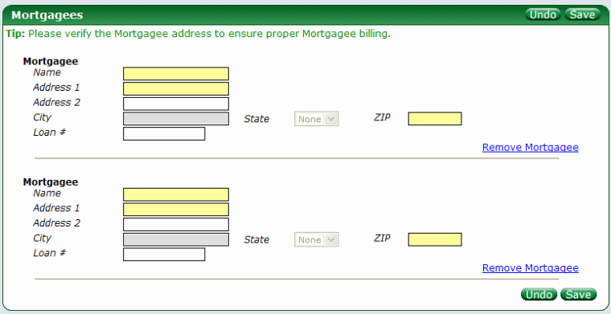

* Mortgagee
  + Name (freeform)
  + Address 1 (freeform)
  + Address 2 (freeform)
  + City (freeform)
    - Disabled until Zip Code is entered. Auto populated by Location Service look-up
    - Can be manually entered
  + State (dropdown) – You will provide
    - Disabled until Zip Code is entered. Auto populated by Location Service look-up
    - Can be manually entered after initial call to Location Service
  + Zip (freeform)
    - Triggers a call to Location Service
  + Loan # (freeform)

**General Information and Notes**

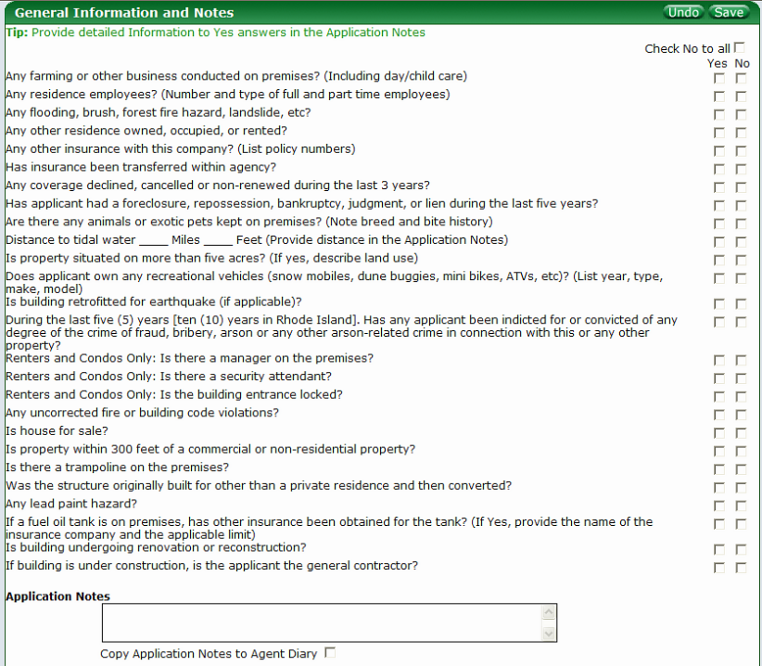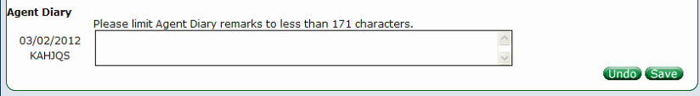

* Check No to all (checkbox)
  + Auto checks all checkboxes for the user
* Questions
  + Filter on LOB, State & Company
    - Will be different based on the above
  + All require a “Yes” or “No” checkbox to be selected
* Application Notes (freeform)
* Copy Application Notes to Agent Diary (checkbox)
  + Copies the Application Notes to the Agent Diary section
* Agent Diary (freeform)

**Billing & Binding Tile (HO-3, HO-4 & HO-6)**

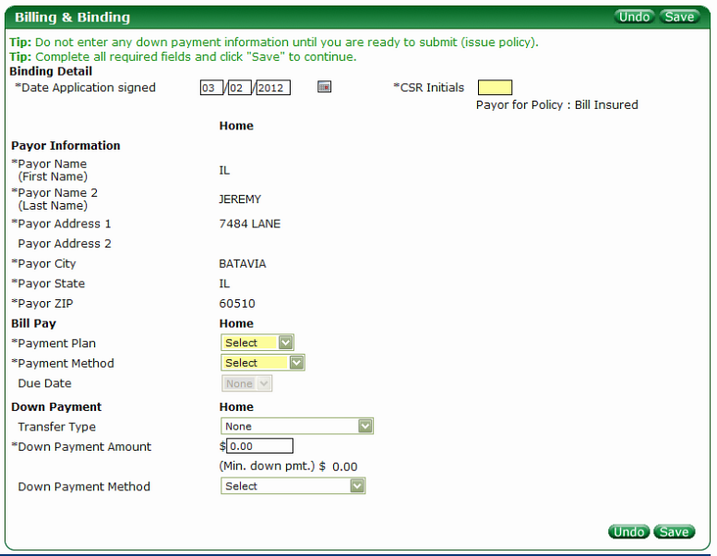

* Date Application signed (freeform)
  + Defaults to current date
* CSR Initials (freeform)
* Payor Information
  + If Payor on Policy Information Tile is “Bill Insured”
    - All Payor Information fields are auto populated with Applicant information from Applicant Tile and not editable
      * Payor Name (First Name)
      * Payor Name 2 (Last Name)
      * Payor Address 1
      * Payor Address 2
      * Payor City
      * Payor State
      * Payor Zip
  + If Payor on Policy Information Tile is “Bill Other”
    - * All Payor Information fields will display for entry
      * Payor Name (First Name) – freeform
      * Payor Name 2 (Last Name) – freeform
      * Payor Address 1 – freeform
      * Payor Address 2 – freeform
      * Payor City
        + Auto populated if zip is found
        + Manual entry if zip is not found
      * Payor State – dropdown – You will provide
        + Auto populated if zip is found
        + Manual entry if zip is not found
      * Payor Zip – freeform
  + If Payor on Policy Information Tile is a “Bill Mortgagee” option
    - All Mortgagee information from the Mortgagee Tile will be auto populated in the Payor Information section
  + Payment Plan (dropdown) – You will provide
    - If Bill Mortgagee option is selected this is disabled
  + Payment Method (dropdown)– You will provide
    - If Bill Mortgagee option is selected this is disabled
    - If EFT is selected

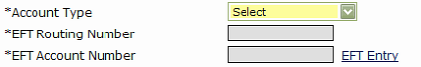

* + - * Due Date (dropdown) opens up
        + If Bill Mortgagee option is selected this is disabled
      * Account Type (dropdown) – You will provide
        + This field becomes available for selection
      * EFT Routing Number (freeform)
        + Disabled - EFT Entry link must be selected
      * EFT Account Number (freeform)
        + Disabled – EFT Entry link must be selected
      * EFT Entry link (link)
        + When select the below pop-up displays

EFT Routing Number (freeform)

Value returned to EFT Routing Number field and disabled

Value is hidden with “X”

Re-enter Routing Number (freeform)

EFT Account Number (freeform)

Value returned to EFT Account Number field and disabled

Value is hidden with “X”

Re-enter Account Number (freeform)

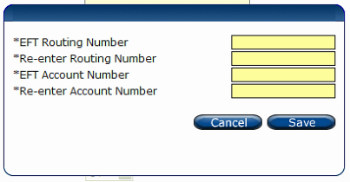

* + - **If MasterCard is selected**

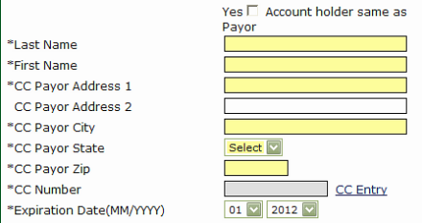

* + - * Yes Account holder same as Payor (checkbox)
        + Auto populates fields with Applicant Information from Applicant Tile
      * Last Name (freeform)
      * First Name (freeform)
      * CC Payor Address 1 (freeform)
      * CC Payor Address 2 (freeform)
      * CC Payor City (freeform)
      * CC Payor State (dropdown) – You will provide
      * CC Payor Zip (freeform)
      * CC Number (freeform)

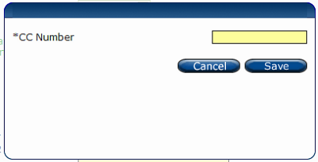

* + - * + Disabled – must select CC Entry link

When selected a pop-up displays

CC Number (freeform)

Value entered is return to CC Number field and disabled

Value is hidden with “X”

* + - * Expiration Date (MM/YYYY) (dropdown) – You will provide
  + Transfer Type (dropdown) – You will provide
    - Filter by State
    - Selection can impact Down Payment required
  + Down Payment Amount (freeform)
    - (Min. down pmt.) $
      * Displays the minimum Down Payment required – You will provide
  + Down Payment Method (dropdown) – You will provide
    - If Bill Mortgagee option is selected this is disabled
    - Based on option selected
      * Same as Auto Bill Pay
        + Auto copies the Bill Pay information for Down Payment
      * MasterCard & Visa are the same as the Bill Pay fields listed above
      * eCheck

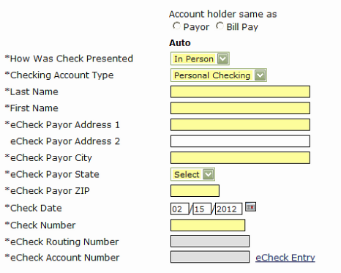

* + - * Account holder same as
        + Payor & Bill Pay (radio buttons)

Payor if selected auto copies Applicant Information from Applicant Tile

Bill Pay if selected auto copies Bill Pay information from Bill Pay section

* + - * How Was Check Presented (dropdown) – You will provide
      * Checking Account Type (dropdown) – You will provide
      * Last Name (freeform)
      * First Name (freeform)
      * eCheck Payor Address 1 (freeform)
      * eCheck Payor Address 2 (freeform)
      * eCheck Payor City (freeform)
      * eCheck Payor State (dropdown) – You will provide
      * eCheck Payor ZIP (freeform)
      * Check Date (freeform)
      * eCheck Routing Number (freeform)
        + Disabled – eCheck Entry link must be selected
      * eCheck Account Number (freeform)
        + Disabled – eCheck Entry link must be selected
      * When select the eCheck link the below pop-up displays

eCheck Routing Number (freeform)

Value returned to EFT Routing Number field and disabled

Value is hidden with “X”

Re-enter Routing Number (freeform)

eCheck Account Number (freeform)

Value returned to EFT Account Number field and disabled

Value is hidden with “X”

* + - * + Re-enter Account Number (freeform)

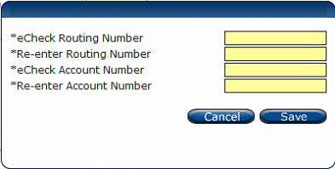

**Blanket Valuable Items**

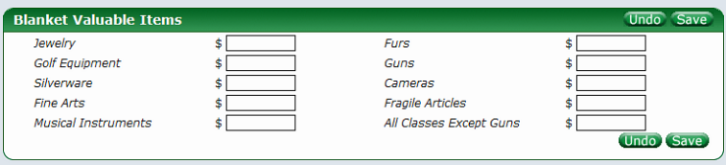

* Jewelry (freeform)
* Furs (freeform)
* Golf Equipment (freeform)
* Guns (freeform)
* Silverware (freeform)
* Cameras (freeform)
* Fine Arts (freeform)
* Fragile Articles (freeform)
* Musical Instruments (freeform)
* All Classes Except Guns (freeform)

**Scheduled Personal Property**

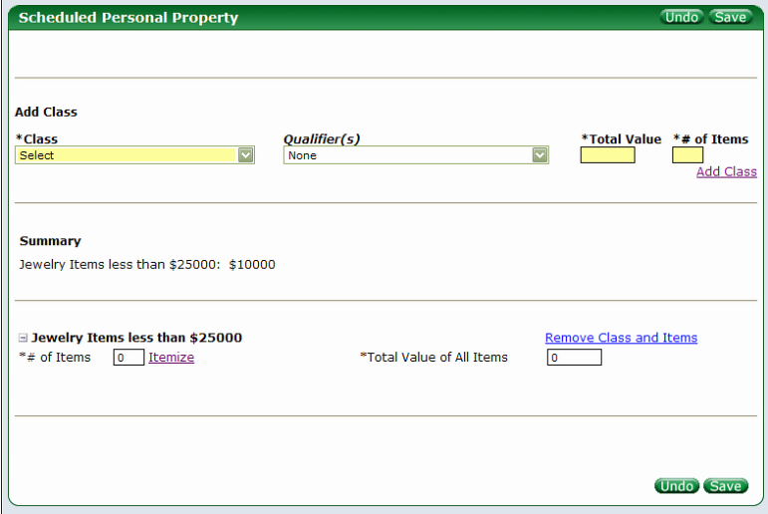

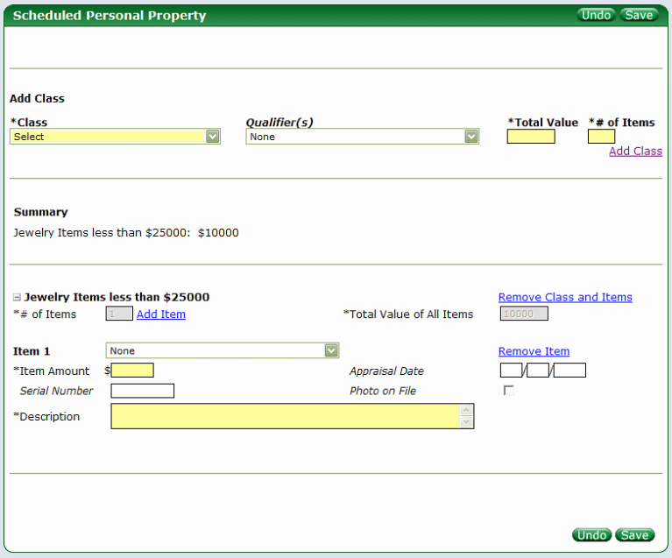

* Add Class
  + Class (dropdown) – You will provide
  + Qualifier(s) (dropdown) – You will provide
  + Total Value (freeform)
  + # of Items (freeform)
  + Add Class (link)
    - Brings down the selection for additional entry fields
    - # of Items (freeform)
      * Disabled with the value from the prior “# of Items” field populated
    - Itemize (link)
      * Opens “Item” fields for entry
        + Then turns into “Add Item” (link)
    - Total Value of All Items (freeform)
      * Disabled and populated with “Total Value” value
    - Item 1 (and all subsequent numbers) (dropdown) – You will provide
    - Item Amount (freeform)
    - Appraisal Date (freeform)
    - Serial Number (freeform)
    - Photo on File (checkbox)
    - Description (freeform)

**Collectibles**

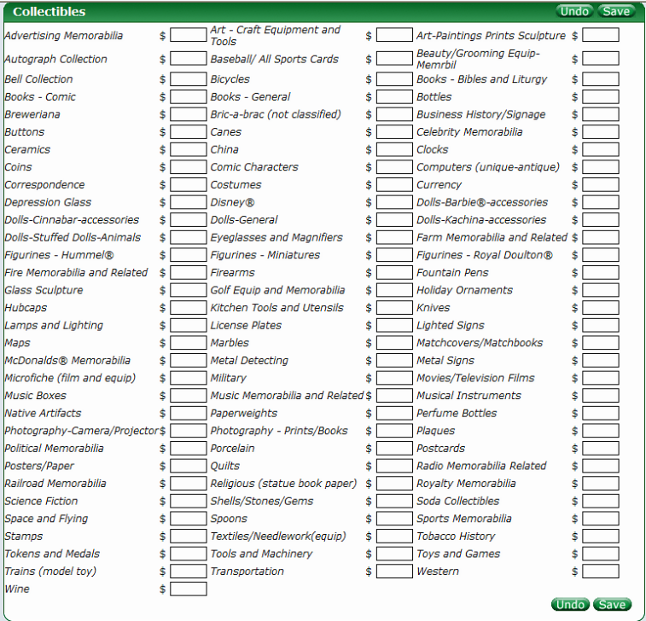

* All values are freeform